CSCI455

Project outline: EMR Requirement definition

Requirement Definition and Specification for the Electronic Medical Record System

February 27th, 2026

Evan Dauenbaugh, Grant Meidinger, Navy Oss

2. Table of Contents
1. Title Page: pg.0
2. Table of Contents: pg.1
3. Brief Background and Project Description: pg.2
4. Requirements Definitions: pg.4
4.1 Functional Requirements: pg.4
4.2 Non-Functional Requirements: pg.6
4.3 Requirement Specifications: pg.7
4.4. Use-Case Diagram: pg.9
4.5 Use-Case Scenarios: pg.10
4.7 Graphical User Interface (GUI) Requirements: pg.11
4.8 System Requirements: pg.12
5. Conceptual Design: pg.14
5.1 Entity-Relationship Diagram (ERD): pg.14
6. Appendix: pg.14
7. References: pg.15

Background
Electronic Medical Record Systems (EMRS), also known as Electronic Medical Record Keeping System (EMRKS), are digital platforms that are used by medical professionals to store, manage, and retrieve patient health information. These systems replaced the old paper-based medical records with a digital database that gives secure, efficient, and organized access to patients' records.
In the past, healthcare workers had to rely on handwritten charts, physical folders, and filling cabinets to manage their patient's information. While this was functional, the paper-based systems provided a number of challenges. Bad handwriting, misplaced records, duplicated documents, and limited access all combined to make it challenging. As healthcare became more complex and collaborative, with the sharing of documents between different hospitals and locations, the limits of paper-based records became even more evident.
The modern EMR systems allow for physicians, nurses, lab techs, administrators, and any other staff the ability to access real-time patient data from centralized databases. The systems support structured medical record storage, secure access control, automated classification of the records, and multi-user access, all of which are outlined in the EMRKS Version 2.0 specification.

Importance of Transitioning Between Paper-Based to Digital Systems
The transition from paper-based medical record keeping to digital EMR systems represents a huge advancement in healthcare information management. The importance of the transition can be better understood by looking at the key benefits:
- Improved Accuracy and Legibility
  - Electronic documentation eliminates the errors caused by illegible handwriting and incomplete entries.
  - Data validation rules ensure that the required fields are completed correctly before being submitted.
- Enhanced Accessibility
  - Authorized users can access patient records from any secure workstation or remote location, which enables faster decision making and improved continuity of care.
- Increased Operational Efficiency
  - Automation of registration and record management reduces paperwork, lowers administrative costs, and improves patient throughput without the need for increasing staff.
- Better Clinical Decision Support
  - EMR systems can provide alerts for drug allergies, abnormal labs, and other preventive care reminders which improve the patient’s safety.
- Secure Data Management
  - By using role-based access control, encryption, and compliance with regulations such as HIPPA, the digital systems provide much stronger protection than any physical means.
This EMRKS project is designed to demonstrate how a well-structured, and database-driven system can address these needs within a healthcare clinical environment, somewhere like the GGFHC.

Project Objectives
The primary goal of the EMRKS is to design and implement a secure, scalable, and user-friendly healthcare management system that meets modern healthcare requirements
The key objectives include:
- Secure Patient Data Management
  - System will ensure that patient data is secured with RBAC, secure logins, and logging user activity, while also complying with HIPAA standards.
- Structured and Organized Medical Records
  - System will use a relational database schema to store patient and hospital data
- Ease of Access for Healthcare Providers
  - System will provide easy to use dashboards and search capabilities
- Patient Portal Accessibility
  - Patients will also have an easy to use process.
- Multi-User Concurrent Access
  - System supports simultaneous access
- Reporting Capabilities
  - System can generate reports for both the patients and healthcare professionals

Scope of the Project
The EMRKS project will cover the following:
- Patient Registration
  - Web based registration
  - Personal information updates
- Secure Login
  - Login will include PINs and 2FA
- Medical Record Storage
  - Structured database storage
  - Clinical notes
  - Lab results
  - Prescriptions
- Appointment Management
  - Viewing appointment history
  - View appointment records
- Patent Portal
  - View and save records
  - Share records
  - View prescription history
- Role-Based Access Control
  - Different levels of access for patients, nurses, physicians, and administrators
- Search and Filters
  - Can search records with different queries and filters
- Basic Reporting
  - Medical history
  - Medication history
  - Appointment history

4. Requirements Definitions
4.1 Functional Requirements (FR –#)
- Core functionalities:
Patient Registration:
  - FR-01: The system will allow new patients to register using the web portal.
  - FR-02: The system will allow patients to log in and update their personal and medical profile information.
  - FR-03: The system will store profile information after updating submission.
  - FR-04: The system will support secure web portal authentication (Username/Password, optional MFA)

Record Creation, Modification, and Retrieval
  - FR-05: The system will allow authorized users (Doctors, Nurses, Admin) to access patient data based on their role.
  - FR-06: The system will allow authorized users to create new patient records.
  - FR-07: The system will allow authorized users to modify existing patient records.
  - FR-08: The system will allow authorized users to look up patient records based on a patient’s identifier or other criteria.
  - FR-09: The system will allow for multiple authorized users to access patient records simultaneously.

Secure Sharing of Records
  - FR-10: The system will allow patients to securely upload and manage documents in their profile.
  - FR-11: The system will allow patients to securely view and download documents in their profile.
  - FR-12: The system will allow authorized users to access patient uploaded data.

Appointment scheduling and management.
  - FR-13: The system will allow patients to view upcoming and past visits.
  - FR-14: The system will allow patients or authorized users to schedule appointments through the GUI.
  - FR-15: The system will allow patients or authorized users to reschedule or cancel appointments.
  - FR-16: The system will provide appointment reminders and notifications for patients and staff.

Reporting and analytics on patient data.
  - FR-17: The system will provide a patient summary report of demographics, allergies, current medications, and recent visits.
  - FR-18: The system will allow patients and authorized users to export patients data such as visits, prescriptions, and lab results to a PDF or CSV file.
  - FR-19: The system will maintain a log report showing which authorized users accessed or modified a patient record and when.

4.2 Non-Functional Requirements (NFR-#)
Performance:
  - NFR-01: The system will allow multiuser access without significant lag or system slow down.
  - NFR-02: The system should return patient records results and reports in an acceptable time frame during normal usage conditions: ~ 5 seconds.
  - NFR-03: The system should load GUI pages and report views within an acceptable time frame during normal usage conditions : ~ 5 seconds.
  - NFR-04: The system will maintain availability and reliability during peak usage conditions.

Security:
  - NFR-05: The system will use and ensure confidentiality and integrity of sensitive data in transmission by using the TLS (Transport Layer Security) encryption protocol.
  - NFR-06: The system will restrict patient data access to authorized users through role-based access control.
  - NFR-07: The system will provide secure login mechanisms including username/password and support MFA.
  - NFR-08: The system will encrypt stored data in rest (database).
  - NFR-09: The system will maintain logs of the patient and authorized users access to patient data and actions taken such as viewing, creating, updating, deleting, and sharing.

Scalability:
  - NFR-10: The system will support growth in the number of patient records and users without requiring a major redesign.
  - NFR-11: The system should support the implementation of additional features in the future without requiring a major redesign.
  - NFR-12: The system should support multiuser access and availability as the system usage increases.

Usability:
  - NFR-13: The system GUI will provide easy navigation with clear menus and well labeled sections.
  - NFR-14: The system will provide search and filtering functionality for finding records and other documents.
  - NFR-15: The system will prompt confirmation for high impact actions such as deleting a record or canceling an appointment.
  - NFR-16: The system will provide clear and easily understood error messages when entering data such as missing requirement fields.

4.3 Requirement Specifications
4.3.1 Functional Requirement table
ID | Specifications
FR-01 | New patient can submit registration via the portal and profile is saved; receives conformation. Feilds: First name, Last name, date of birth, phone/email, address, emergency contact.
FR-02 | A patient can log in, edit profile fields, save changes, and updates persist after refresh/logins. Patient can update only their own profile; staff can edit patient profile only if role permits.
FR-03 | After submitting updates, the system stores the new values and displays them correctly.
FR-04 | Username/password works; MFA if enabled prompts before access is granted. Password must be hidden during entry; unsuccessful login returns “Wrong username or password”.
FR-05 | Doctor/Nurse/Admin access is restricted by role; unauthorized users can't access protected data. Nurses can access basic patient information and edit basic information (contact info, allergies, vitals, notes). Doctors can view full patient records, create/modify documents. Admin access patient and staff accounts roles and permissions and reporting/ logging.
FR-06 | Authorized users can create a new patient record and retrieve it. Record creation must be linked to exactly one patient.
FR-07 | Authorized users can edit an existing record and changes persist; The system will maintain an edit history and log indicating who modified the record and when.
FR-08 | Users can search for patient records via identifier in a search function; Correct record is returned. Search results are restricted based on role permissions.
FR-09 | Two authorized users can access the same patient record without error or data loss.
FR-10 | A patient can upload a document and it appears in the patients document list with correct information; Encrypted in transit and at rest. Allowed file types: PDF, PNG/JPG.
FR-11 | A patient can open and download documents. Patients can only access their own documents; download will contain original file contents.
FR-12 | Authorized staff can view patients uploaded documents; unauthorized users cannot access them.
FR-13 | Patient can view a list of upcoming and past visits; details are correct.
FR-14 | Appointments can be scheduled through the GUI and appear in the appointment list for patients and staff. Required fields: date, time, clinic address, appointment type.
FR-15 | Appointments can be rescheduled/ canceled; status is updated in the appointment list for patients and staff.
FR-16 | System generates reminder/notification for upcoming appointments.
FR-17 | System generates a patient summary including demographics, allergies, medications, and recent visits.
FR-18 | User can export selected patient data to PDF or CSV file; contains the correct data.
FR-19 | Audit log records who accessed/modified a record. Feilds: user Identifier, role, action type, timestamp.

4.3.2 Non-Functional Requirement table
ID | Specifications
NFR-01 | Multiuser system remains responsive and does not crash or time out.
NFR-02 | Under normal load (25 users), record searches and reports return within ~5 seconds
NFR-03 | Under normal load (25 users), GUI pages and report views load within ~5 seconds
NFR-04 | During peak usage conditions, the system remains available
NFR-05 | All traffic uses HTTPS/TLS; non-TLS connections are blocked
NFR-06 | RBAC prevents unauthorized access; attempts are denied and logged. Actions to access must be checked for view/edit/create/delete.
NFR-07 | Login requires username/password; MFA if enabled.
NFR-08 | Stored patient data is encrypted at rest (database data encrypted). All patient records and uploaded documents are stored on the server.
NFR-09 | System logs key actions (view/create/update/delete/upload/download) with the user taking those actions. Feilds: user Identifier, role, action type, timestamp.
NFR-10 | System design supports increasing records/ users without major changes to the core design.
NFR-11 | Architecture supports adding future modules without redesigning core components.
NFR-12 | System can maintain multiuser access and availability as usage grows
NFR-13 | Users can reach major functions (records, appointments, profile) through clear menus. Menu labels: Records, Appointments, Documents, and Profile.
NFR-14 | Search and filtering finds results accurately and returns correct records and documents.
NFR-15 | High impact actions prompt confirmation and do not execute unless confirmed.
NFR-16 | Invalid or missing input triggers a clear error message showing what needs to be corrected (Required fields, invalid formats (email/date))

4.4. Use-Case Diagram

Figure 1: Use Case Diagram for Electronic Medical Record System
Figure 1 shows the use case diagram for our EMR System. It shows the four actors; patients, nurses, doctors, and administrators. It shows how these actors interact with our system and what kind of access each actor has. All rounded boxes inside of the EMRS are each use case that actors can interact with while using our system interface.
4.5 Use-Case Scenarios
- Example Scenario 1: Doctor accessing a patient's medical history.
Use Case Title | View Medical Records (For Doctors)
Preconditions | Selected patient is registered in system  and has valid medical records present
Scope | Selected Patient's Medical records
End Conditions | Success: Doctor views patient's medical  records  Failure: Doctor doesn't successfully view  patient medical records
Actors | Primary: Doctor  Secondary: EMR System
Description | A doctor can view patient's medical  records remotely

- Example Scenario 2: Administrator adding a new patient record.
Use Case Title | Admin creating a new patient record
Preconditions | Admin has correct permissions in system  and patient is not currently in system
Scope | List of patients and records
End Conditions | Success: Admin adds a new patient to  list of patients  Failure: Admin fails to add new patient  to list of patients
Actors | Primary: Admin  Secondary: EMR System
Description | An admin can create new patients and  add their information to the list of patients

- Example Scenario 3: Patient booking an appointment through a portal.
Use Case Title | Patient Booking an Appointment
Preconditions | Patient is currently registered in system  and selected appointment slot is available
Scope | List of patient info and appointment  time slots
End Conditions | Success: Patient successfully adds an  appointment to the schedule  Failure: Patient fails to add an  appointment to the schedule
Actors | Primary: Patient  Secondary: EMR System
Description | A patient can schedule an appointment  with their selected time and doctor

4.7 Graphical User Interface (GUI) Requirements
4.7.1 Login Page: Provides secure access for patients, doctors, nurses, and administrators.
  - Username/email field
  - Password field
  - Sign In Button
  - Optional MFA prompt
  - Role aware login handling (patient vs staff)
  - Clear labels and error messages
  - Responsive layout for desktop usage
  - Password field covered by default and option to see plain text

4.7.2 Dashboard for Staff: Primary navigation and viewing for staff users.
- Navigation menu (Patients, Appointments, Records, Reports, Settings)
- Search bar for patient lookup
- Summary panels (appointments, alerts, updates)
- Notification area (new lab results, appointment reminders, record changes)
- Quick actions (Add Patient, Open Record, Schedule Appointment)
- Intuitive navigation with labeled sections
- Search and filtering functionality

4.7.3 Dashboard for Patients: Primary navigation and viewing for a patient's information.
- Patient demographic section (Name, DOB, contact info)
- Medical summary section (allergies, conditions, medications)
- Edit functionality for patients personal information (Address, Emergency contact, phone number, email)
- Record history section (labs, prescriptions, appointments)
- Clearly sections for personal and medical data
- Confirmation message after data updates
- Role-based edit permissions
4.7.4 Appointment Scheduling Page: Page accessible to both patients and staff to create, view, and manage appointments.
- Date and time selection
- Appointment type
- Available slot display
- Book, Reschedule, Cancel buttons
- Upcoming and past appointment list
- Clear confirmation messages after booking or changes
- Easy navigation between upcoming and past appointments

System Requirements
Server Hardware Requirements
- Processor: Quad Core 2.5GHz+
- RAM: 16GB
- Storage: 1TB
- Network: Gigabit ethernet
- Backup System: Cloud Based
User Hardware Requirements
- Must be desktop computer
- Processor: Dual Core 2.0 GHz
- RAM: 8GB
- Modern Browser (Edge, Chrome, Firefox)
- Secure Internet Connection

Software Requirements

Operating Systems
- Server:
  - Windows Server
- User:
  - Windows 11
  - MacOS
  - Linux Distros
Database Management Systems
- MySQL
Development Framework
- Backend:
  - C# / .NET
- Frontend:
  - Visual Studio
- Version Control:
  - GitHub

Compliance Requirements
The EMRKS will comply with the following regulations:
HIPAA
The system must ensure:
- Confidentiality of Protected Health Information
- Integrity of Medical Records
- Secure authentication and access control
- Data encryption

Data Protection Standards
If used internationally, the system will also follow GDPR:
- Encrypted data storage
- Secure transmission protocols
- Periodic security audits
- User access logs

5. Conceptual Design
5.1 Entity-Relationship Diagram (ERD)
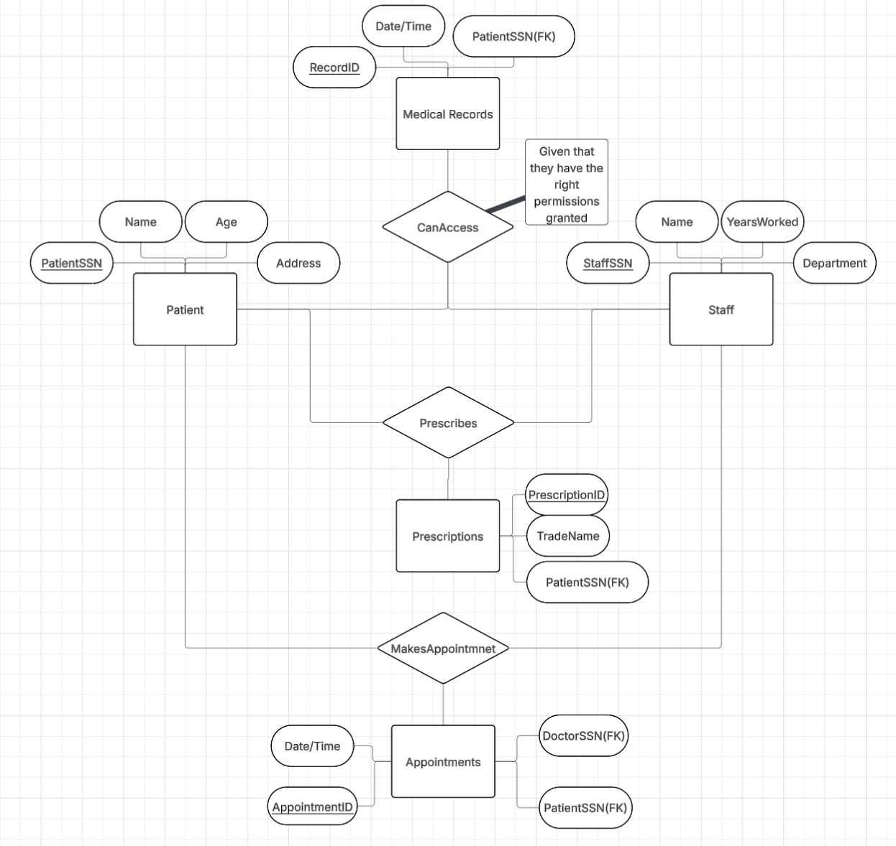
Figure 2: Entity Relationship Diagram for Electronic Medical Record System
Figure two showcases our ERD for our EMR system. The key features are the relationships between each of the entities in our system, as well as the attributes for each entity. Primary keys for each entity are the underlined attributes, and foreign keys(FK) are labeled as such. This is a very high-level version of future ERDs.
6. Appendix
- 2FA – Two Factor Authentication
- DBMS – Database Management System
- DOB – Date of Birth
- EMRKS – Electronic Medical Records Keeping System
- EMRS – Electronic Medical Records System
- ERD – Entity Relationship Diagram
- FR – Functional Requirement
- GGFHC – Greater Grand Forks Healthcare Clinic
- GUI – Graphical User Interface
- HIPAA – Health Insurance Portability and Accountability Act
- MFA – Multi Factor Authentication
- NFR – Non-Functional Requirement
- PHI – Protected Health Information
- RBAC – Role Based Access Control

7. References
- HIPAA - Health Information Privacy | HHS.gov

